MQ2 LPG GAS SENSOR:

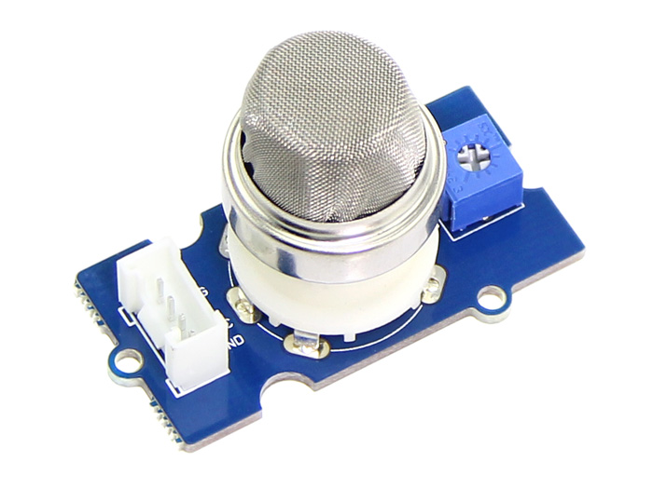

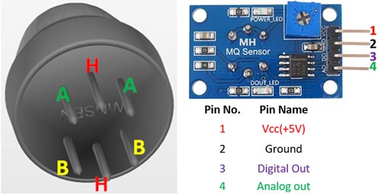

The Grove - Gas Sensor(MQ2) module is useful for gas leakage detection (home and industry). It is suitable for detecting H2, LPG, CH4, CO, Alcohol, Smoke or Propane. Due to its high sensitivity and fast response time, measurement can be taken as soon as possible. The sensitivity of the sensor can be adjusted by potentiometer.

Features[¶](http://wiki.seeedstudio.com/Grove-Gas_Sensor-MQ2/#features)

* Wide detecting scope
* Stable and long lifetime
* Fast response and High sensitivity

Specification[¶](http://wiki.seeedstudio.com/Grove-Gas_Sensor-MQ2/#specification)

| Item | Parameter | Min | Typical | Max | Unit |
| --- | --- | --- | --- | --- | --- |
| VCC | Working Voltage | 4.9 | 5 | 5.1 | V |
| PH | Heating consumption | 0.5 | - | 800 | mW |
| RL | Load resistance |  | adjustable |  |  |
| RH | Heater resistance | - | 33 | - | Ω |
| Rs | Sensing Resistance | 3 | - | 30 | kΩ |

|  |  |  |
| --- | --- | --- |
| **For Module** | | |
| 1 | Vcc | This pin powers the module, typically the operating voltage is +5V |
| 2 | Ground | Used to connect the module to system ground |
| 3 | Digital Out | You can also use this sensor to get digital output from this pin, by setting a threshold value using the potentiometer |
| 4 | Analog Out | This pin outputs 0-5V analog voltage based on the intensity of the gas |

### Features:

* Operating Voltage is +5V
* Can be used to Measure or detect LPG, Alcohol, Propane, Hydrogen, CO and even methane
* Analog output voltage: 0V to 5V
* Digital Output Voltage: 0V or 5V (TTL Logic)
* Preheat duration 20 seconds
* Can be used as a Digital or analog sensor
* The Sensitivity of Digital pin can be varied using the potentiometer